John Robinson

* ANN
* CNN research
* <https://towardsdatascience.com/a-comprehensive-guide-to-convolutional-neural-networks-the-eli5-way-3bd2b1164a53>
* <https://youtu.be/YRhxdVk_sIs>
* <https://youtu.be/iaSUYvmCekI>
* A scholarly article about how CAPTCHA works in general in a broad sense. No exact code mostly informative on the subject and the failings of CAPTCHA.

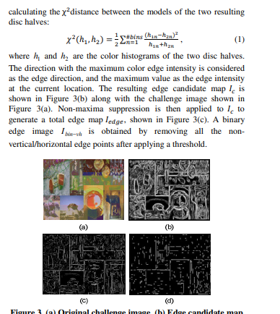

Bin B. Zhu Microsoft Research Asia, et al. “Attacks and Design of Image Recognition CAPTCHAs.” *Attacks and Design of Image Recognition CAPTCHAs | Proceedings of the 17th ACM Conference on Computer and Communications Security*, 1 Oct. 2010, dl.acm.org/doi/pdf/10.1145/1866307.1866329.

* This paper will explain how deep learning is applied to the field of image recognition, and will also explain the latest trends of deep learning-based autonomous driving.

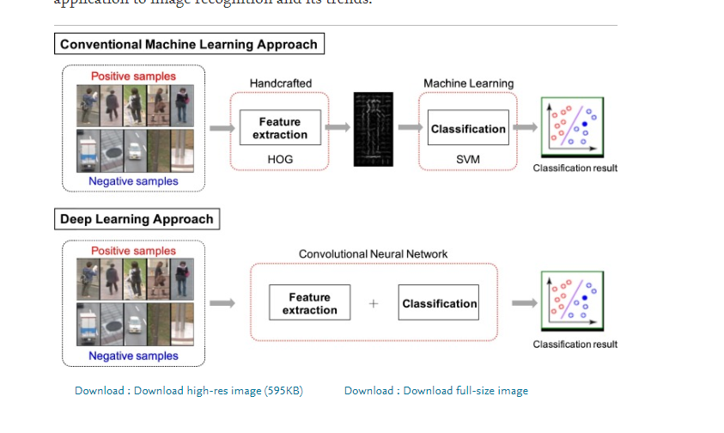

Fujiyoshi, Hironobu, et al. “Deep Learning-Based Image Recognition for Autonomous Driving.” *IATSS Research*, Elsevier, 6 Dec. 2019, www.sciencedirect.com/science/article/pii/S0386111219301566.

* In this paper, a new scheme is proposed for a FER system based on hierarchical deep learning .In addition, we propose a technique to generate facial images with neutral emotion using the autoencoder technique. By this technique, dynamic facial features between the neutral and emotional images without sequence data. They compare the proposed algorithm with the other recent algorithms for CK+ and JAFFE dataset.
* 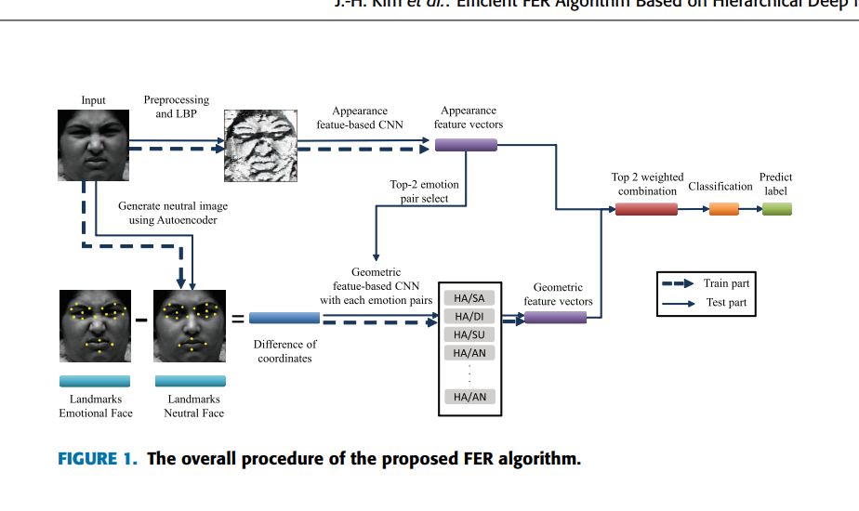

“Efficient Facial Expression Recognition Algorithm Based on Hierarchical Deep Neural Network Structure.” *IEEE Xplore*, ieeexplore.ieee.org/document/8673885.

* Very informative article which is somewhat broad on the subject of medical image recognition ai in relation to separate medical fields. Might be too simplistic as a source will investigate further.
* # to broad removing this

Chen, Hao, and Joseph J Y Sung. “Potentials of AI in Medical Image Analysis in Gastroenterology and Hepatology.” *Wiley Online Library*, John Wiley & Sons, Ltd, 15 Jan. 2021, onlinelibrary.wiley.com/doi/full/10.1111/jgh.15327.

* This scholarly article discuss the image recognition–based structured report generation system (ISRGS), which works through deep learning CNN models combining real-time video capture, site identification, diagnosis of GI lesions and their subcharacteristics analysis, and structured report generation. The primary objective of the study was to test the diagnostic performance of ISRGS using multicenter and prospective data sets.
* Perhaps too medical in nature

Qu, Jun-Yan, et al. “Development and Validation of an Automatic Image-Recognition Endoscopic Report Generation System: A Multicenter Study.” *Clinical and Translational Gastroenterology*, Wolters Kluwer, 22 Dec. 2020, [www.ncbi.nlm.nih.gov/pmc/articles/PMC7771723](http://www.ncbi.nlm.nih.gov/pmc/articles/PMC7771723)

* In this scholarly article. It is demonstrated how Grad-CAM heatmaps can be used to increase the explainability of an image recognition model trained for a pedestrian underpass
* Need to read more dont really understand

Borg, Markus, et al. “Test Automation with Grad-CAM Heatmaps -- A Future Pipe Segment in MLOps for Vision AI?” *ArXiv.org*, 2 Mar. 2021, arxiv.org/abs/2103.01837.

* Very Interesting scholarly article concept. Applying image recognition ai to gacha games.This research article purpose is to create a bot that can replace the user task to click buttons on game stages, thus helping users in their grinding.

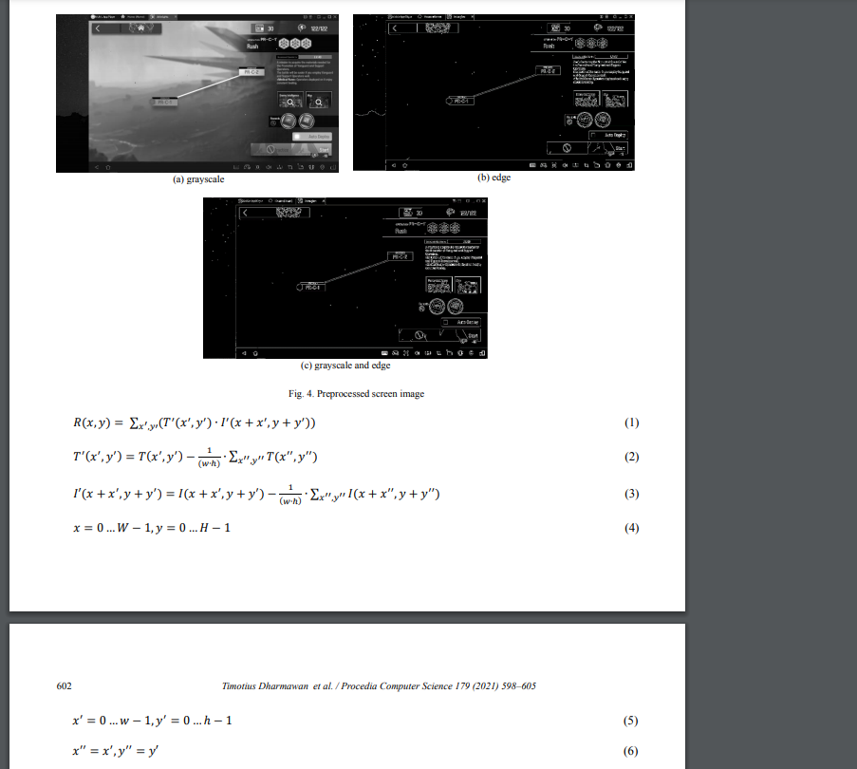

Dharmawan, Timotius, and Novita Hanafiah. “Clicker Bot for Gacha Games Using Image Recognition.” *Procedia Computer Science*, Elsevier, 19 Feb. 2021, www.sciencedirect.com/science/article/pii/S1877050921000521.

* Technical Report, somewhat old but informative about PCA and fisher discriminant based image recognition algorithms. It discusses the subspace created by the eigenvectors of the covariance matrix of the training data and the subspace created by the Fisher basis vectors of the data. Experiments are presented comparing recognition rates for different similarity measures and spaces using hand labeled imagery from two domains: human face recognition and classifying an image as a cat or a dog.
* Want to understand math behind it seems very complex.

Yambor, Wendy S. “ANALYSIS OF PCA-BASED AND FISHER DISCRIMINANT-BASED IMAGE RECOGNITION ALGORITHMS.” *Citeseerx*, July 2000, citeseerx.ist.psu.edu/viewdoc/download?doi=10.1.1.440.5963&rep=rep1&type=pdf.

* Some websites no comment yet

Olafenwa, Moses. “Train Image Recognition AI with 5 Lines of Code.” *Medium*, Towards Data Science, 5 Jan. 2021, towardsdatascience.com/train-image-recognition-ai-with-5-lines-of-code-8ed0bdd8d9ba.

Rafia 7 months ago · 10 min read, et al. “Blog.” *LogicAI*, 20 Dec. 2019, logicai.io/blog/using-artificial-intelligence-ai-image-recognition/.

Editor. “Image Recognition with Deep Neural Networks and Its Use Cases.” *AltexSoft*, AltexSoft, 13 Jan. 2020, www.altexsoft.com/blog/image-recognition-neural-networks-use-cases/.

https://www.apriorit.com/dev-blog/599-ai-for-image-processing

Probably useless

<https://deepomatic.com/en/introduction-to-computer-vision-and-image-recognition>

Just a google product

<https://cloud.google.com/vision>

Chen, Hao, and Joseph J Y Sung. “Potentials of AI in Medical Image Analysis in Gastroenterology and Hepatology.” *Wiley Online Library*, John Wiley & Sons, Ltd, 15 Jan. 2021, onlinelibrary.wiley.com/doi/full/10.1111/jgh.15327.

Too broad

For a source manager I used Purdue Owl to generate the sources for me. Doesnt feel very efficient I think I will try Zotero

<https://owl.purdue.edu/owl/research_and_citation/mla_style/mla_formatting_and_style_guide/mla_general_format.html>

